

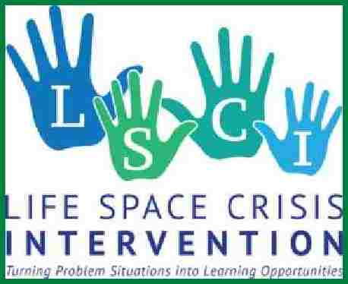

Life Space Crisis Intervention Certification Workshop
Register now – only 32 openings available each session
*Certified participants may attend for review if registered

This certification training provides carefully structured theoretical and applied instruction in crisis intervention skills for use in reclaiming children and youth involved in patterns of self-defeating behavior. Life Space Crisis Intervention (LSCI) applies to troubled and at-risk students in various education settings. The training provides 27 specific competencies for using the crisis as a teaching and therapeutic opportunity with students showing six different patterns of self-defeating behavior.

Learning Outcomes:
1. Articulate the dynamics of conflict cycles, which lead to self-defeating behavior.
2. Recognize student-thinking errors that interfere with communication and problem-solving.
3. Recognize the process and outcomes of staff counter-aggression, which precludes effective intervention.
4. Assess the circumstances under which LSCI is or is not an appropriate intervention.
5. Demonstrate effective de-escalation, decoding, and counseling strategies for youth in crisis.
  - 6. Differentially diagnose these six common patterns of self-defeating behavior:
  - a. Problems originating elsewhere in a child’s ecology.
  - b. Problems rooted in a child’s reality distortions.
  - c. Problems resulting from social skill deficits.
  - d. Problems related to negative peer influence.
  - e. Problems caused by lack of prosocial values.
  - f. Problems of guilt and self-abusive behavior.
7. Match specific reclaiming interventions with each of the six patterns of self-defeating behavior.
8. Utilize a six-step sequence and specific communication skills for each reclaiming intervention.
9. Reflect on how certain youth problems relate to the helper’s personality and values.

Facilitator: Danielle Theis, Master Trainer of Life Space and National Consultant on Mental Health. She is one of 30 Master Trainers for Life Space Crisis Intervention in the world. danielletheisconsulting.com teachtoheal.org
Danielle has been working successfully with youth who experience mental health and behavioral challenges since 1990. Through her development of Teach to Heal, she prides herself in assisting schools with a systemic approach to support mental health and the impact of trauma. Danielle is a licensed psychotherapist. She has served as an Educational Administrator for 23 years including as Director of Special Education and K-12 Principal. She is acknowledged by the Minnesota Department of Education as an expert in reducing restrictive procedures and working effectively with children who display significant behavioral challenges. Danielle provides consultation and training to support children experiencing mental health and behavioral challenges, and the adults who serve them, in our schools and communities.
Registration fee: $1,000 and includes the required materials & book ($175 value) and one-year membership in Iowa ASCD.
- Certified participants attending as a refresher, fee is $200.
- School Counselors who are members of ISEA and their local association will be funded through Ross Trust Reserve Funds that pays for registration, lodging, books and Grad Credit/LR Credit.
Attendance at this training certifies an individual to use the strategies. It does not allow a participant to train on Life Space concepts or materials.
Credit options (Free for ISEA Member School Counselors)
- Iowa License Renewal 2 credits $ 70 –through ISEA Academy
- 3 Graduate Credits - Augustana College - $300 –through Danielle Thies. (School Counselors who are ISEA members can be reimbursed through Ross Trust)
Registration: https://iowaascd.org events tab
Cost: $1,000 (no cost for ISEA School Counselor members)
Certified participants attending as a refresher, fee is $200.

